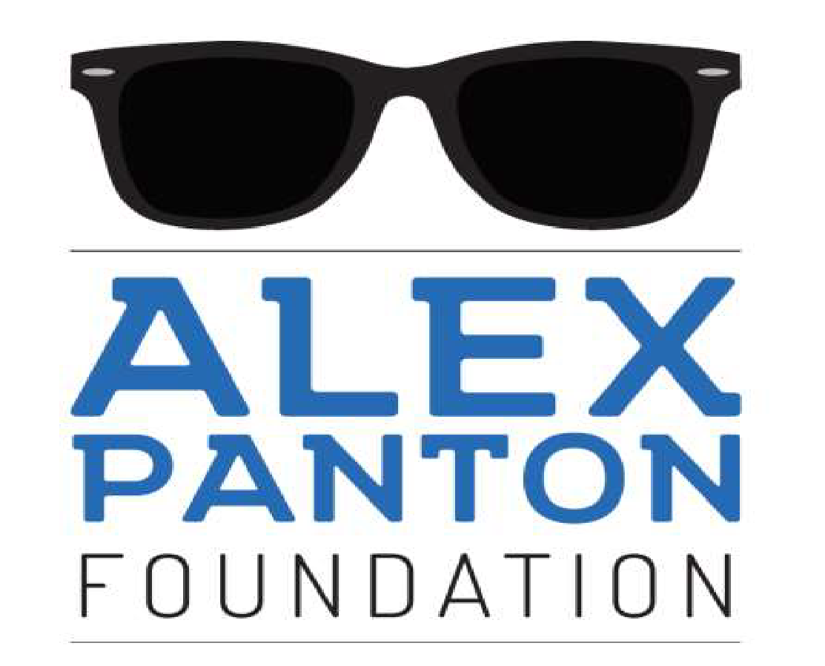

Overcoming the Stigma of Mental Illness
Focusing on the youth of Cayman
Alex Panton Foundation
Box 326 Grand Cayman, KY1- 1501
info@alexpantonfoundation.ky
Insert Date

Insert Company

Insert contact

Attention: Insert contact person name

Dear ,

Alex Panton Foundation Fundraising Initiatives

The Alex Panton Foundation (“APF”) was established in the memory of Alex Panton, who succumbed to the effects of severe depression at the age of 16. It is therefore APF’s mission to improve the mental health of the children and young adults of the Cayman Islands like Alex, through advocacy, education, and unwavering support. Enclosed in this letter is the executive summary of the APF, which includes a brief history and its mission and goals. Further information can be found on the APF website: www.alexpantonfoundation.ky.

APF has been ardently working to raise awareness of the effects of mental illnesses on the youth population since our launch in February 2018 and subsequent registration as a Cayman Islands Non-Profit Organisation in June 2018. That same year, our Clinical and Education Committee (“C&E Committee”) partnered with the National Drug Council (“NDC”) to obtain comprehensive mental health statistics from children across all high schools in the Cayman Islands. The resulting data collected informed the C&E Committee to make several recommendations for programmes and initiatives that would best support the mental health needs of the local youth, all of which are outlined in this letter. Some of these programmes are run in partnership with other charities and community organisations, such as: the YMCA, Special Needs Foundation, TAYA Lounge, Family Resource Centre, Ministry of Community Affairs, and local churches.

APF is proudly equipped with a highly-qualified clinical team who volunteer their time to provide clinical consultation and educational services; other professional leads who volunteer their time to provide legal, out-reach, and creative services; and other dedicated, inspiring community volunteers. Without all of their undulating support, our ability to grow and have meaningful impact would be impossible. It is with your help, however, that we will be able to implement and sustain our intensive clinical and evidence-based programmes, for APF to fully realize our mission of creating a safer, more compassionate community within the Cayman Islands.

Presently, we are looking to fund the programmes outlined below.

Emotional Literacy Programme

Cost: CI$76,000 per annum

The APF has purchased a copyright license to an internationally recognised evidence-based programme to develop the emotional literacy of children aged 5 to 9 years old. The two divisions currently being offered, Zippy’s Friends (ages 5-7) and Apple’s Friends (ages 7-9), commenced in November 2019. The programme is designed to help children develop skills to communicate effectively and cope with everyday emotional events. An adapted programme, SEND (Special education needs and disability), is specific to children with moderate to severe intellectual disabilities, and the Cayman Islands will be the first country in the world to establish a fully-inclusive programme by introducing children with special needs from its implementation.

Founded by the UK’s Partnership for Children, these programmes are widely used in over 30 countries around the world and recognised by the World Health Organization. These programmes teach life skills at a young age when children are developing emotionally and physically, with the goal of producing healthier and emotionally resilient adults, as the building blocks for an accepting and compassionate society.

APF is pleased to announce the launch of the next cycle (2020-2021) of the Emotional Literacy Programme. As of October 2020, upwards of 150 teachers and 22 schools have signed up for the Emotional Literacy Programme. With your help, APF will be better equipped to managed the extensive costs of this programme, including: licensing fees, training for teachers and master trainers, support visits, royalty fees, and supporting materials.

The Emergency Adolescent Mental Health Hub

Cost:
CI$27,000 - Emergency response vehicle/Mobile unit
CI$100,100 - Furnishing of “The Hub” rooms
CI$6,000 – Website for text line/chat line

The 2020 Cayman Islands Student Drug Use Survey (CISDUS) determined that 27 per cent of all students surveyed reported in engaging in self-harming behaviours; that 17 per cent of all students surveyed reported experiencing suicidal ideation; and that 8.9 per cent of all students surveyed reported attempting suicide. However, only about 5 per cent of young people who have reported attempted suicide sought help. The barriers to receiving treatment were identified as a lack of public service resources (there being only one dedicated children and young person psychiatrist in the public health service) and a lack of a dedicated facility for young people to seek help when they are in crisis.

APF has been working with the Health Services Authority (HSA) and Mental Health Commission to develop a children and adolescent mental health hub (“The Hub”). The Hub team will consist of specialist child and adolescent health workers, including a Psychiatrist, a Clinical Psychologist, Community Psychiatric Nurses, a Mental Health Social Worker, and an Occupational Therapist. The staffing expenses for this project is supported by the Ministry of Health in its 2020-21 approved budgets, but ongoing funding is needed to launch important elements of the project. A full version of the proposal can be provided upon request.

As the HSA is supporting the refurbishment of The Hub, APF is seeking specific funding for the following:

- An emergency response vehicle to carry out community/home visits and assist with outreach community services for schools and the community;
- Furnishing the room allocated at the Cayman Islands Hospital that will function as the Hub;
- A text line / chat line / extension to help young people access help directly.

While the aforementioned reported risk factors for suicide in 2020 have decreased since the 2018 CISDUS, this leaves a significant portion of the youth at risk for suicide (student N = 387) and self-injury (N = 626), emphasizing the need for a The Hub and mobile mental health unit to cater to and access these vulnerable individuals. APF believes that the proposed service model will make it easier for youth to seek and access help in a professionally supported environment where they can feel safe. APF plans for a basic crisis response service to commence by February 2021, with plans for The Hub to be available by mid-2021.

Financial Assistance Programme
Cost: CI$25,000 per annum
The APF recognises that for many young people struggling with mental health issues, the cost of treatment is beyond what is covered by most health insurance providers. While we await the completion of the Cayman Islands mental health facility and the Mental Health Emergency Hub at HSA, APF has created a fund to assist those in need of financial support to access in-patient treatment abroad, and local private mental health care providers' facilities for outpatient and counselling services. For treatments abroad, the fund will be used towards flights, room and board, and the inpatient/outpatient treatment programme approved by the individual's insurance provider. For local outpatient treatments, the cost not covered by insurance will be paid directly to the service provider. The individuals will be selected on a needs-based assessment by our board of directors, following recommendations by the C&E Committee. Your support of this programme will mean improving accessibility to the critical and emergent care necessary to protect our youth suffering from mental illnesses.

Administrative Coordinator
Cost: CI$25,000 per annum
The APF is seeking an individual to assist us in: liaising between our multiple pathways and divisions, especially the Chair and the C&E Committee; managing our organisation’s multiple inboxes; responding to requests on social media and the APF website; forwarding and delegating tasks to relevant volunteers; arranging meetings and assisting with events and other APF projects; updating the Board on relevant tasks and events; managing our accounting and finances; overseeing the implementation of and collecting data for the Emotional Literacy Programme; and developing any other pathways and initiatives directed by the C&E Committee. As this is an essential and demanding post to maintain, your support would ensure that the successful candidate has the means to keep our volunteer-based team afloat.

Annual Symposium
Cost: CI$22,000 per annum (Details of cost break down available upon request.)
Every February since our launch in 2018, the APF hosts an annual mental health symposium featuring several speakers from various perspectives on mental illness, including: persons living with and overcoming mental illness, parents, counsellors, and mental health service providers. The symposium aims to shed a light on services and treatments available to those suffering with mental health issues and to discuss issues affecting youth mental health today. The last three Symposiums have been free to attend due to funding from generous community sponsors.

Support Groups
Cost: CI$ 3,000 per annum
The APF offers a free peer-led support group for young adults ages 18-30, which functions as a safe space for those suffering in silence to share their thoughts, feelings, and stories in a welcoming environment. The group is entirely confidential, and the goal is to create a community where young people can offer peer support and guidance over the shared and complicated experiences of struggling with one’s mental health.
APF is currently planning the implementation of a second, online support group for youth ages 13-18, in order to reach more vulnerable individuals with especially limited access to mental health services. This group would virtually meet 1-2 times a month, under the supervision of a local Clinical Psychologist and Life Coach. The funding of these support groups will offer greater access for young persons to have a safe space to consult a professional on their mental health amongst likeminded peers.

Youth Ambassador Programme

Cost: CI$4,000 per annum

The Youth Ambassador Programme (“YAP”) was created by APF to provide support to the youth of Cayman who experience mental health challenges, in particular anxiety and depression, by building resilience and inspiring hope through the very young people developing their own path forward within the programme. YAP aims to inspire young people to offer peer support through empathy, understanding and active listening.

This programme offers adolescents the opportunity to earn the title of “Youth Ambassador” through fun activities designed to challenge specific skills and provoke discussion on enacting the necessary social changes for a consciously intersectional and inclusive society. Participants have the opportunity to interact with other teens and collaborate on ideas beyond the programme, as well.

YAP’s Youth Ambassadors are provided with exceptional opportunities to represent Cayman’s youth, such as: presenting testimonials at public events, hosting youth visual arts competitions, engaging in policy discussions, and participating in focus groups to discern how the youth can be best supported. Throughout the year, our Youth Ambassadors work on campaigns to promote the importance of understanding mental health issues and breaking the stigma of discussing mental health. In 2019, YAP’s campaigns focused on topics of: anxiety and depression, drugs and alcohol use, and keeping safe. Our Youth Ambassadors are provided with the necessary resources to connect with their peers and encouraged recruit more Youth Ambassadors into the programme. YAP is designed to validate what young people are experiencing, recognise their strengths, and inform and/or connect them with other resources if needed. With your support, we can continue to assist these gifted and emotionally-intelligent young persons in teaching their peers how to support themselves as well as how to ask for help.

Outreach – Psychoeducational Community Workshops
Cost: CI$2,000 per annum
The APF’s presentations are prepared and presented by on a volunteer basis by our C&E Committee. These presentations include talks focused on anxiety and depression designed for schools and local organisations, as well as skills-based workshops in collaboration with the Ministry of Community Affairs for community leaders in mental health management, namely self-harm and suicide, in tandem with organisations such as: the YMCA, churches, and educational providers. For this initiative, APF only needs support to meet a small cost required for printing brochures based on relevant presentation topics. These presentations are vital to our outreach in supporting and educating the public on mental health disorders at an accessible, personable level, in an environment which invites curiosity or uncertainty to evolve into compassion and understanding.
For each of our initiatives, there is an option to align your company’s name with the programme or service for the term of your commitment as the sole sponsor for the full amount required. If you are interested in assisting us with sponsorship toward any of these initiatives or would like to discuss our initiatives further, please contact Shane Purcell at shanehpurcell@gmail.com or on +1 345 324 4455.

Yours sincerely,

Shane Purcell
Board Member, Head of Fundraising and Support Group Facilitator
Alex Panton Foundation

